Take existing template and revise

This is an auto email that fires when someone fills out a form on our website

If needed, all stock photos we own are here for use if needed: <https://thoughtstopaper-my.sharepoint.com/:f:/p/tchow/EsuasNjoU4RMky9I2xGjxukBjaUg5MN10vRySgZg8aTICQ?e=aSL22N>

Can also use new ones from shutterstock as needed and we can buy.



Revise if you have good ideas. It is okay right now, but if you have better idea. This first section is to say thanks for visiting our website, we’ll contact you soon.

Second part is, while waiting for us to contact client, please read some of our articles. They are all related to patents. Not sure if a better photo can be used instead. If you can think of something better, show me, otherwise this is okay.

\*\*

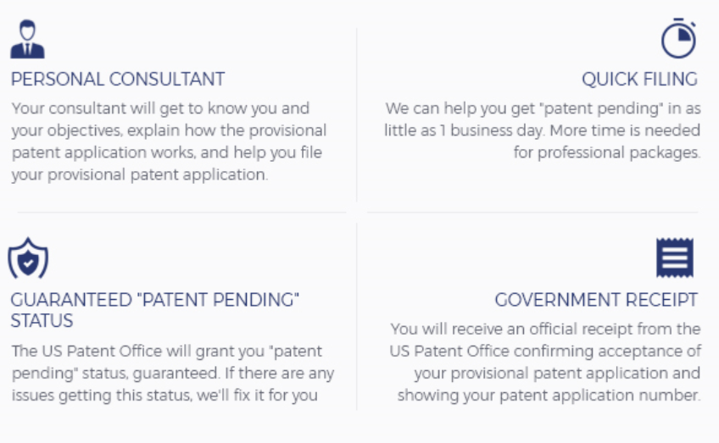

This area replace with

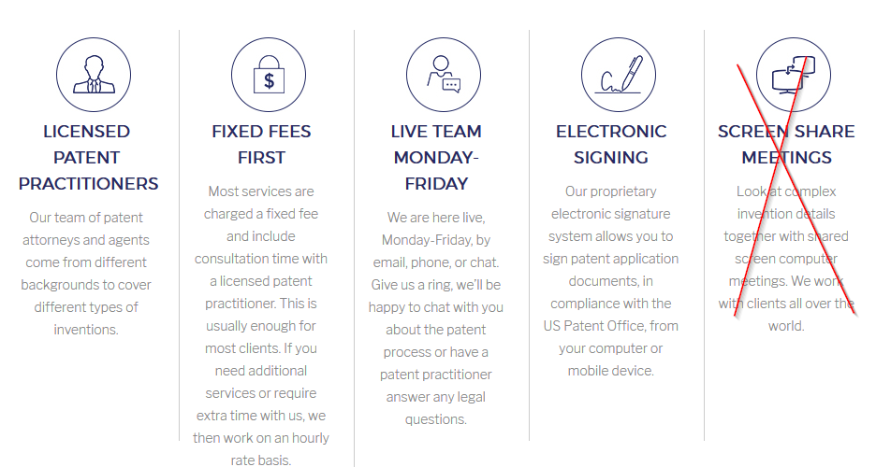

From here

<https://www.thoughtstopaper.com/>

But maybe 2 x 2, as in 2 rows of 2, like before. As maybe easier to read in an email than 4 tall columns

\*\*

This can be removed



\*\*



Update so that it shows

1. Star rating
2. Name and date
3. “Title”
4. And part of review

Like this:



But it will not be dynamic, we will put in static reviews in the email but still have same elements, star, name, date, title, review

\*\*

Add link to go to more reviews page

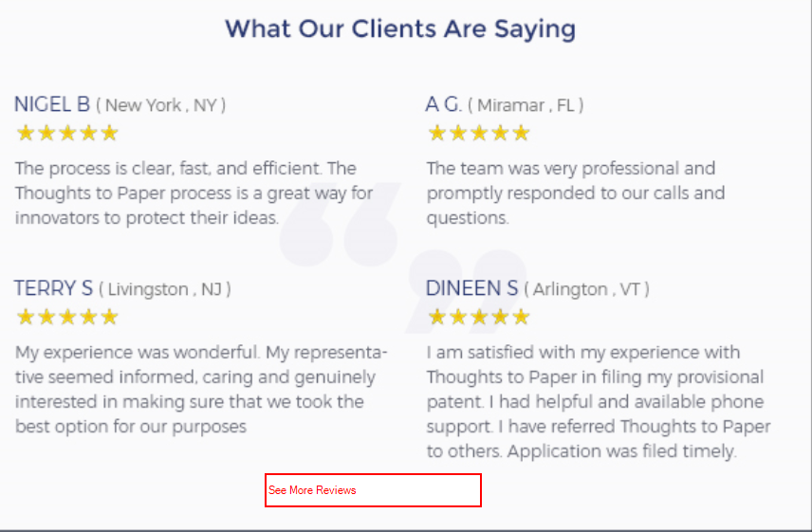

\*\*



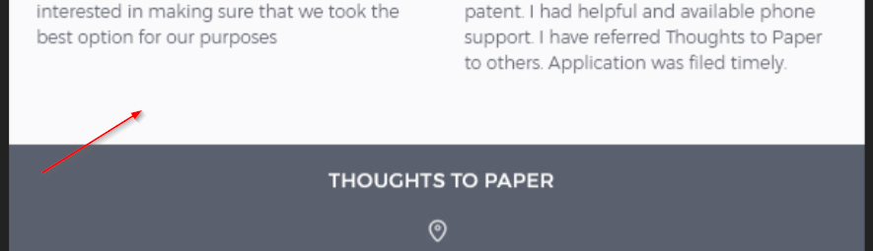

Put a portion of the infographic to allow user to click and go to full infographic blog post here:

<https://www.thoughtstopaper.com/blog/how-a-provisional-patent-application-works/>

User needs to know that they can access full infographic by clicking

\*\*

Make footer look better?

